# CPU SCHEDULING ALGORITHM :- FCFS, PRIORITY, SJP, ROUND ROBIN

#include<stdio.h>

#include<stdlib.h>

typedef struct process{

char name[5];

int bt;

int at;

int prt;

int wt,ta;

int flag;

}processes;

void b_sort(processes temp[],int n)

{

processes t;

int i,j;

for(i=1;i<n;i++)

for(j=0;j<n-i;j++){

if(temp[j].at > temp[j+1].at){

t = temp[j];

temp[j] = temp[j+1];

temp[j+1] = t;

}

}

}

int accept(processes P[]){

int i,n;

printf("\n Enter total no. of processes : ");

scanf("%d",&n);

for(i=0;i<n;i++){

printf("\n PROCESS [%d]",i+1);

printf(" Enter process name : ");

scanf("%s",&P[i].name);

printf(" Enter burst time : ");

scanf("%d",&P[i].bt);

printf(" Enter arrival time : ");

scanf("%d",&P[i].at);

printf(" Enter priority : ");

scanf("%d",&P[i].prt);

}

printf("\n PROC.\tB.T.\tA.T.\tPRIORITY");

for(i=0;i<n;i++)

printf("\n %s\t%d\t%d\t%d",P[i].name,P[i].bt,P[i].at,P[i].prt);

return n;

}

// FCFS Algorithm

void FCFS(processes P[],int n){

processes temp[10];

int sumw=0,sumt=0;

int x = 0;

float avgwt=0.0,avgta=0.0;

int i,j;

for(i=0;i<n;i++)

temp[i]=P[i];

b_sort(temp,n);

printf("\n\n PROC.\tB.T.\tA.T.");

for(i=0;i<n;i++)

printf("\n %s\t%d\t%d",temp[i].name,temp[i].bt,temp[i].at);

sumw = temp[0].wt = 0;

sumt = temp[0].ta = temp[0].bt - temp[0].at;

for(i=1;i<n;i++){

temp[i].wt = (temp[i-1].bt + temp[i-1].at + temp[i-1].wt) - temp[i].at;;

temp[i].ta = (temp[i].wt + temp[i].bt);

sumw+=temp[i].wt;

sumt+=temp[i].ta;

}

avgwt = (float)sumw/n;

avgta = (float)sumt/n;

printf("\n\n PROC.\tB.T.\tA.T.\tW.T\tT.A.T");

for(i=0;i<n;i++)

printf("\n %s\t%d\t%d\t%d\t%d",temp[i].name,temp[i].bt,temp[i].at,temp[i].wt,temp[i].ta);

printf("\n\n GANTT CHART\n ");

for(i=0;i<n;i++)

printf(" %s ",temp[i].name);

printf("\n ");

printf("0\t");

for(i=1;i<=n;i++){

x+=temp[i-1].bt;

printf("%d ",x);

}

printf("\n\n Average waiting time = %0.2f\n Average turn-around = %0.2f.",avgwt,avgta);

}

//SJF Non Pre-emptive

void SJF_NP(processes P[],int n){

processes temp[10];

processes t;

int sumw=0,sumt=0;

int x = 0;

float avgwt=0.0,avgta=0.0;

int i,j;

for(i=0;i<n;i++)

temp[i]=P[i];

b_sort(temp,n);

for(i=2;i<n;i++)

for(j=1;j<n-i+1;j++){

if(temp[j].bt > temp[j+1].bt){

t = temp[j];

temp[j] = temp[j+1];

temp[j+1] = t;

}

}

printf("\n\n PROC.\tB.T.\tA.T.");

for(i=0;i<n;i++)

printf("\n %s\t%d\t%d",temp[i].name,temp[i].bt,temp[i].at);

sumw = temp[0].wt = 0;

sumt = temp[0].ta = temp[0].bt - temp[0].at;

for(i=1;i<n;i++){

temp[i].wt = (temp[i-1].bt + temp[i-1].at + temp[i-1].wt) - temp[i].at;;

temp[i].ta = (temp[i].wt + temp[i].bt);

sumw+=temp[i].wt;

sumt+=temp[i].ta;

}

avgwt = (float)sumw/n;

avgta = (float)sumt/n;

printf("\n\n PROC.\tB.T.\tA.T.\tW.T\tT.A.T");

for(i=0;i<n;i++)

printf("\n %s\t%d\t%d\t%d\t%d",temp[i].name,temp[i].bt,temp[i].at,temp[i].wt,temp[i].ta);

printf("\n\n GANTT CHART\n ");

for(i=0;i<n;i++)

printf(" %s ",temp[i].name);

printf("\n ");

printf("0\t");

for(i=1;i<=n;i++){

x+=temp[i-1].bt;

printf("%d ",x);

}

printf("\n\n Average waiting time = %0.2f\n Average turn-around = %0.2f.",avgwt,avgta);

}

//Priority Non Pre-emptive

void PRT_NP(processes P[],int n)

{

processes temp[10];

processes t;

int sumw=0,sumt=0;

float avgwt=0.0,avgta=0.0;

int i,j;

int x = 0;

for(i=0;i<n;i++)

temp[i]=P[i];

b_sort(temp,n);

for(i=2;i<n;i++)

for(j=1;j<n-i+1;j++){

if(temp[j].prt > temp[j+1].prt){

t = temp[j];

temp[j] = temp[j+1];

temp[j+1] = t;

}

}

printf("\n\n PROC.\tB.T.\tA.T.");

for(i=0;i<n;i++)

printf("\n %s\t%d\t%d",temp[i].name,temp[i].bt,temp[i].at);

sumw = temp[0].wt = 0;

sumt = temp[0].ta = temp[0].bt - temp[0].at;

for(i=1;i<n;i++){

temp[i].wt = (temp[i-1].bt + temp[i-1].at + temp[i-1].wt) - temp[i].at;;

temp[i].ta = (temp[i].wt + temp[i].bt);

sumw+=temp[i].wt;

sumt+=temp[i].ta;

}

avgwt = (float)sumw/n;

avgta = (float)sumt/n;

printf("\n\n PROC.\tB.T.\tA.T.\tW.T\tT.A.T");

for(i=0;i<n;i++)

printf("\n %s\t%d\t%d\t%d\t%d",temp[i].name,temp[i].bt,temp[i].at,temp[i].wt,temp[i].ta);

printf("\n\n GANTT CHART\n ");

for(i=0;i<n;i++)

printf(" %s ",temp[i].name);

printf("\n ");

printf("0\t");

for(i=1;i<=n;i++){

x+=temp[i-1].bt;

printf("%d ",x);

}

printf("\n\n Average waiting time = %0.2f\n Average turn-around = %0.2f.",avgwt,avgta);

}

//Round Robin Scheduling

void RR(processes P[],int n)

{

int pflag=0,t,tcurr=0,k,i,Q=0;

int sumw=0,sumt=0;

float avgwt=0.0,avgta=0.0;

processes temp1[10],temp2[10];

for(i=0;i<n;i++)

temp1[i]=P[i];

b_sort(temp1,n);

for(i=0;i<n;i++)

temp2[i]=temp1[i];

printf("\n Enter quantum time : ");

scanf("%d",&Q);

for(k=0;;k++){

if(k>n-1)

k=0;

if(temp1[k].bt>0)

printf(" %d %s",tcurr,temp1[k].name);

t=0;

while(t<Q && temp1[k].bt > 0){

t++;

tcurr++;

temp1[k].bt--;

}

if(temp1[k].bt <= 0 && temp1[k].flag != 1){

temp1[k].wt = tcurr - temp2[k].bt - temp1[k].at;

temp1[k].ta = tcurr - temp1[k].at;

pflag++;

temp1[k].flag = 1;

sumw+=temp1[k].wt;

sumt+=temp1[k].ta;

}

if(pflag == n)

break;

}

printf(" %d",tcurr);

avgwt = (float)sumw/n;

avgta = (float)sumt/n;

printf("\n\n Average waiting time = %0.2f\n Average turn-around = %0.2f.",avgwt,avgta);

}

//Shortest Job First - Pre-emptive

void SJF_P(processes P[],int n){

int i,t_total=0,tcurr,b[10],min_at,j,x,min_bt;

int sumw=0,sumt=0;

float avgwt=0.0,avgta=0.0;

processes temp[10],t;

for(i=0;i<n;i++){

temp[i]=P[i];

t_total+=P[i].bt;

}

b_sort(temp,n);

for(i=0;i<n;i++)

b[i] = temp[i].bt;

i=j=0;

printf("\n GANTT CHART\n\n %d %s",i,temp[i].name);

for(tcurr=0;tcurr<t_total;tcurr++){

if(b[i] > 0 && temp[i].at <= tcurr)

b[i]--;

if(i!=j)

printf(" %d %s",tcurr,temp[i].name);

if(b[i]<=0 && temp[i].flag != 1){

temp[i].flag = 1;

temp[i].wt = (tcurr+1) - temp[i].bt - temp[i].at;

temp[i].ta = (tcurr+1) - temp[i].at;

sumw+=temp[i].wt;

sumt+=temp[i].ta;

}

j=i; min_bt = 999;

for(x=0;x<n;x++){

if(temp[x].at <= (tcurr+1) && temp[x].flag != 1){

if(min_bt != b[x] && min_bt > b[x]){

min_bt = b[x];

i=x;

}

}

}

}

printf(" %d",tcurr);

avgwt = (float)sumw/n; avgta = (float)sumt/n;

printf("\n\n Average waiting time = %0.2f\n Average turn-around = %0.2f.",avgwt,avgta);

}

//Priority Preemptive

void PRT_P(processes P[],int n){

int i,t_total=0,tcurr,b[10],j,x,min_pr;

int sumw=0,sumt=0;

float avgwt=0.0,avgta=0.0;

processes temp[10],t;

for(i=0;i<n;i++){

temp[i]=P[i];

t_total+=P[i].bt;

}

b_sort(temp,n);

for(i=0;i<n;i++)

b[i] = temp[i].bt;

i=j=0;

printf("\n GANTT CHART\n\n %d %s",i,temp[i].name);

for(tcurr=0;tcurr<t_total;tcurr++)

{

if(b[i] > 0 && temp[i].at <= tcurr)

b[i]--;

if(i!=j)

printf(" %d %s",tcurr,temp[i].name);

if(b[i]<=0 && temp[i].flag != 1)

{

temp[i].flag = 1;

temp[i].wt = (tcurr+1) - temp[i].bt - temp[i].at;

temp[i].ta = (tcurr+1) - temp[i].at;

sumw+=temp[i].wt;

sumt+=temp[i].ta;

}

j=i;

min_pr = 999;

for(x=0;x<n;x++){

if(temp[x].at <= (tcurr+1) && temp[x].flag != 1){

if(min_pr != temp[x].prt && min_pr > temp[x].prt){

min_pr = temp[x].prt;

i=x;

}

}

}

}

printf(" %d",tcurr);

avgwt = (float)sumw/n;

avgta = (float)sumt/n;

printf("\n\n Average waiting time = %0.2f\n Average turn-around = %0.2f.",avgwt,avgta);

}

int main(){

processes P[10];

int ch,n;

do{

printf("\n\n SIMULATION OF CPU SCHEDULING ALGORITHMS\n");

printf("\n Options:");

printf("\n 0. Enter process data.");

printf("\n 1. FCFS");

printf("\n 2. SJF (Pre-emptive)");

printf("\n 3. SJF (Non Pre-emptive)");

printf("\n 4. Priority Scheduling (Pre-emptive)");

printf("\n 5. Priority Scheduling (Non Pre-emptive)");

printf("\n 6. Round Robin");

printf("\n 7. Exit\n Select : ");

scanf("%d",&ch);

switch(ch){

case 0:

n=accept(P);

break;

case 1:

FCFS(P,n);

break;

case 2:

SJF_P(P,n);

break;

case 3:

SJF_NP(P,n);

break;

case 4:

PRT_P(P,n);

break;

case 5:

PRT_NP(P,n);

break;

case 6:

RR(P,n);

break;

case 7:exit(0);

}

}while(ch != 7);

getch();

return 0;

}

**OUTPUT :-**

MAIN MENU

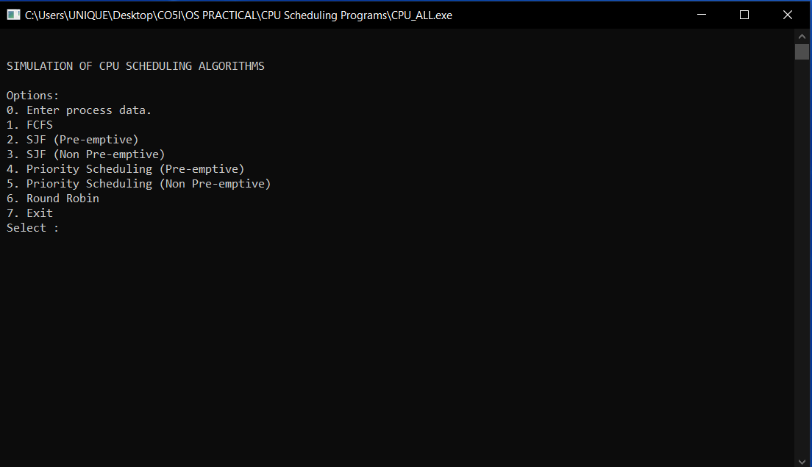

INSERT DATA

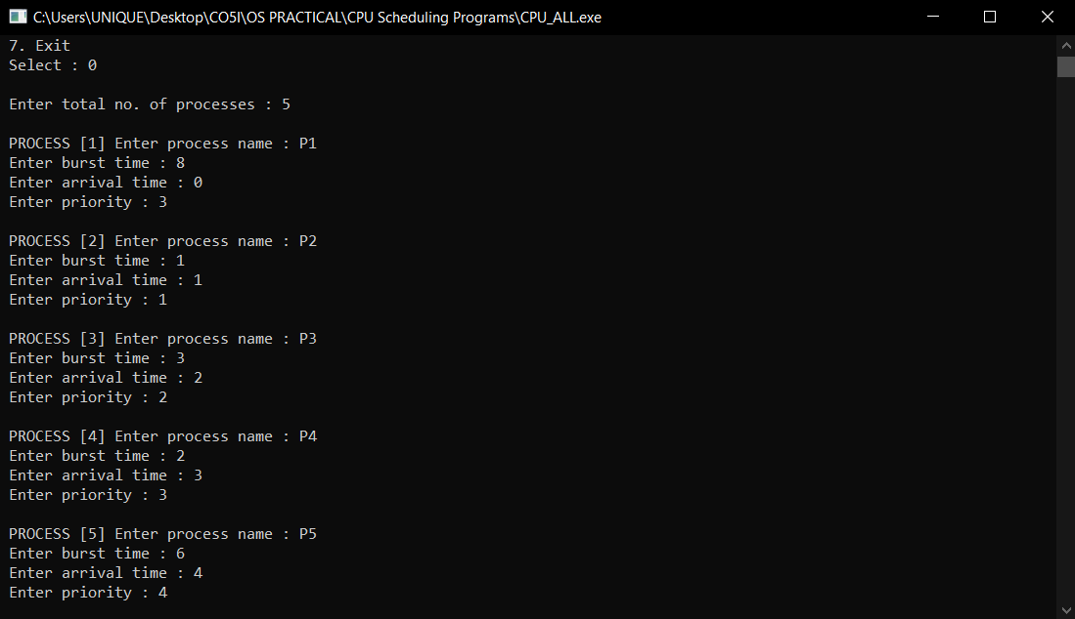

FCFS

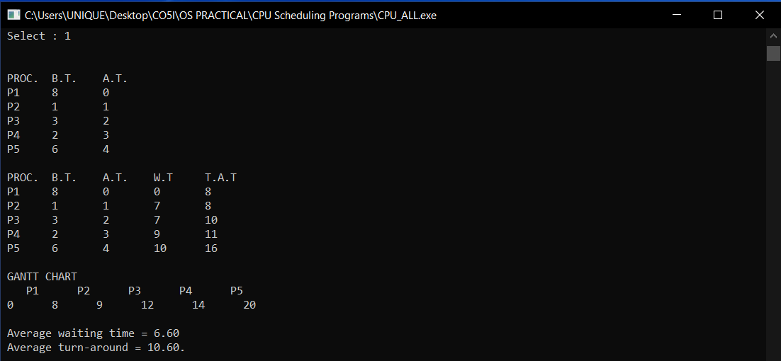

SJP NON PREEMPTIVE

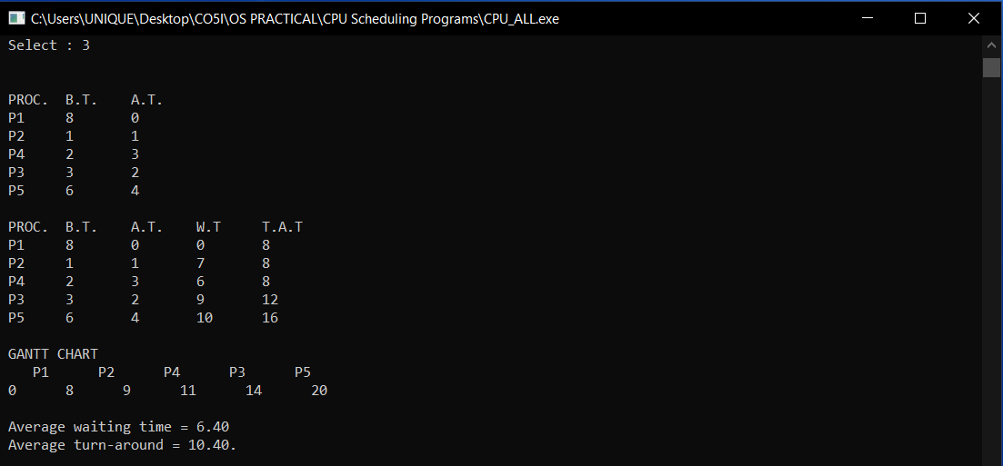

PRIORITY NON PREEMPTIVE

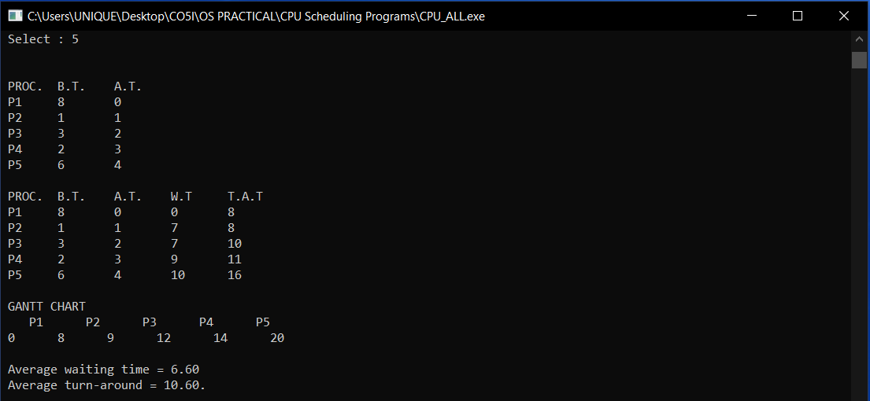

ROUND ROBIN

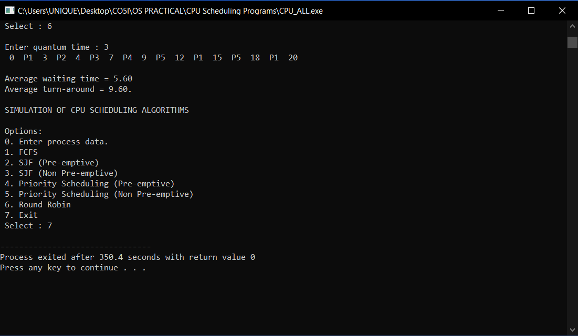

SJP PREEMPTIVE

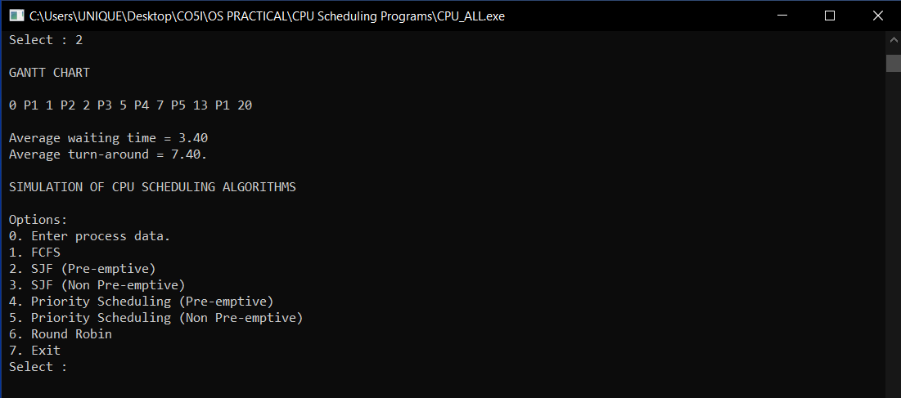

PRIORITY PREEMPTIVE

